**3F. Ipconfig, ping, traceroute and netstat**

1. **Ipconfig:**

* Displays the current information about the network connected. Such as IP and MAC address of the router along with the DHCP and DNS servers.
* IP address of a device mainly helps in identifying the connection of a network
* The MAC Address, on the other hand, ensures the computer device's physical location.
* Dynamic Host Configuration Protocol (DHCP) is a client/server protocol that automatically provides an Internet Protocol (IP) host with its IP address and other related configuration information such as the subnet mask and default gateway.
* A Domain Name System (DNS) turns domain names into IP addresses, which allow browsers to get to websites and other internet resources.

**Output:**

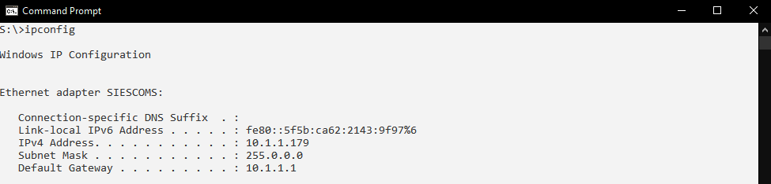

1. **Ipconfig/all**

**Output:**

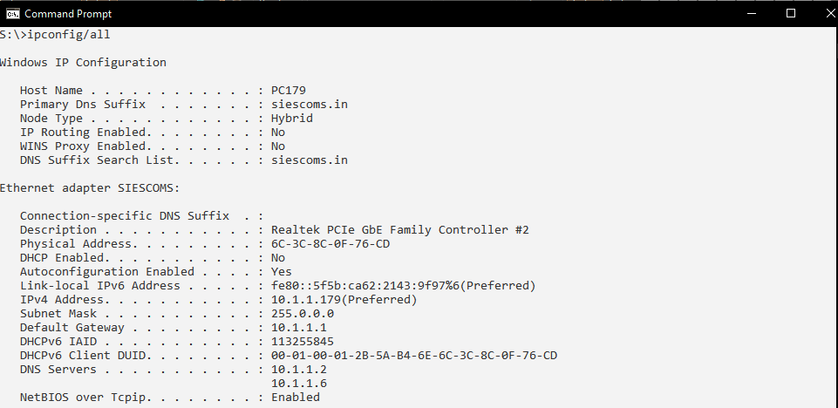

1. **Ping** www.goog`1sle.com

**Output:**

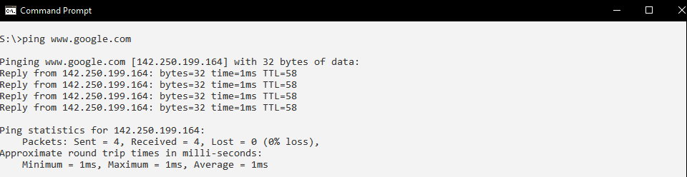

1. **tracert** [www.google.com](http://www.google.com)

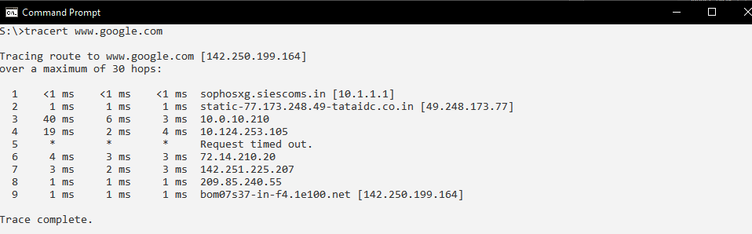

1. **netstat**

**Output:**

